# Introduction:

The amount of times your heart beats each minute is known as your heart rate. According to Healthline.com, your heart rate is never in a steady beat. When a person is at rest and calm, their heart rate is frequently monitored. This is known as your resting heart rate. Because you're at rest, your resting heart rate is when your heart pumps the smallest quantity of blood that your body requires. Individual resting heart rates can differ. Your resting heart rate can also be affected by factors such as age, exercise level, and certain drugs.

The aim of the experiment is to determine the cardiovascular health in teenagers ages 15 – 17 by recording the average heart rate of an individual while in resting stage and then recording their beats per minute (bpm). According to Healthline.com, the average heart rate for children above 10yrs of age is 60 to 100 bpm (beats per minute). Resting heart rate may differ between females and males. Other factors which may affect resting heart rate either by increasing or decreasing includes: (Healthline.com)

* Temperature – increased if exposed to hot temperatures
* Medication side effects – may lower resting heart rate
* Emotions – anxious or excited (increase)
* Weight – overweight (increases)
* Anaemia – low level of red blood cells (increases)
* Hormonal abnormalities – either increase or decrease heart rate
* Etc.

There are three main ways to lower your BPM. (Harvard Health Publishing)

1. Exercise more - When you take a brisk walk, swim, or bicycle, your heart beats faster during the activity and for a short time afterward. But exercising every day gradually slows the resting heart rate.
2. Reduce stress - Performing the relaxation response, meditation, tai chi, and other stress-busting techniques lowers the resting heart rate over time.
3. Lose weight (if necessary) - The larger the body, the more the heart must work to supply it with blood. Losing weight can help slow an elevated resting heart rate.

To help maintain a healthy heart, you can: (Health.gov)

* Eat healthy
* Get active
* Stay at a healthy weight
* Quit smoking and stayaway from second-hand smoke (VAPE)
* Control cholesterol levels
* Drink alcohol only in moderations
* Manage stress

# Hypothesis:

It is hypothesised that those who exercise more throughout the week will have a lower resting heart rate than those who only exercise one or two days. This is because when you take a brisk walk, swim or bicycle, your heart rate beats faster during the activity and for a short time afterwards. But exercising everyday gradually slows the resting heart rate (Harvard Health Publishing). The lower the BPM, the better. Results must be between 60 to 100 BPM for an average teenager.

## Variables:

**Independent Variable:** How many days they exercise per week

**Dependent Variable:** Heart rate

**Controlled Variable:**

* How long the heart rate was calculated for – 30 seconds
* All heart rates were taken 3 times – average is the final number (answer)
* All heart rates taken while participants were in resting stage

# Materials:

* 25 or more Humans – The participants
* 1 - Paper – to record the data
* 1 - Pen – to write
* 1 - Stopwatch/phone – to time the heart rate within 30 seconds (must double afterwards to find the BPM)

# Methods:

Students were seated in their classrooms and in a resting state when their heartrate was recorded. To record the heart rates, place either two fingers on the base of the wrist until a beat is felt or place two fingers under the base of the neck, under the jawline, until a beat is felt. Each student/participant’s heart rate was measured three times for a duration of 30 seconds. This is done to ensure the reliability of the test. The heart rates were later on doubled to find the BPM. Then the average of the 3 heart rates was used later on as the final result. All data were recorded in a table including the gender, each trial of heart rate recorded, amount of days of exercise per week and average bpm. The data recorded for the participants are located in the Data/Results heading, under the table subheading. Each individual’s confidentialities were kept hidden as they were only addressed as subject 1, subject 2 and so forth.

# Data/Results:

## Table:

|  |  |  |  |  |  |  |
| --- | --- | --- | --- | --- | --- | --- |
|  |  | Resting Heart rate (beats/minute) | | |  |  |
| Subject | Exercise (days per week) | 1 | 2 | 3 | Average (BPM) | Gender |
| 1 | 1-2 | 70 | 72 | 68 | 70 | F |
| 2 | 1-2 | 78 | 70 | 70 | 72 | F |
| 3 | 2-3 | 66 | 68 | 66 | 67 | F |
| 4 | 1-2 | 66 | 62 | 72 | 67 | F |
| 5 | 2-3 | 80 | 80 | 80 | 80 | M |
| 6 | 3-4 | 66 | 70 | 70 | 69 | M |
| 7 | 3-4 | 80 | 82 | 84 | 80 | M |
| 8 | 4 | 71 | 72 | 74 | 72 | M |
| 9 | 5 | 94 | 102 | 100 | 99 | M |
| 10 | 5+ | 50 | 52 | 53 | 52 | F |
| 11 | 1-2 | 96 | 88 | 86 | 90 | F |
| 12 | 1-2 | 78 | 76 | 78 | 77 | F |
| 13 | 3-4 | 50 | 50 | 44 | 48 | F |
| 14 | 1-2 | 54 | 52 | 50 | 52 | F |
| 15 | 3-4 | 60 | 65 | 63 | 63 | M |
| 16 | 1-2 | 80 | 82 | 88 | 83 | F |
| 17 | 1 | 90 | 94 | 89 | 91 | F |
| 18 | 5 | 67 | 61 | 59 | 62 | M |
| 19 | 4-5 | 56 | 60 | 64 | 58 | M |
| 20 | 3 | 90 | 85 | 81 | 85 | M |
| 21 | 5 | 55 | 57 | 57 | 56 | M |
| 22 | 2-3 | 45 | 49 | 53 | 49 | F |
| 23 | 5+ | 50 | 49 | 51 | 50 | F |
| 24 | 1 | 89 | 83 | 85 | 86 | F |
| 25 | 2 | 78 | 81 | 82 | 80 | M |

*Table of the recorded resting heart rates of students in 11 ATAR Human Bio. Class plus extra.*

## Graphs/Charts:

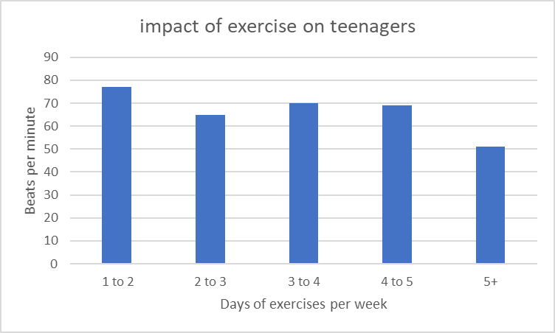

As seen from the trend of the table, those who exercise more throughout the week tend to have a lower BPM compared to those who only exercise 1-2 days per week.

# References

* *Increase in resting heart rate is a signal worth watching - Harvard Health*. Harvard Health. (2022). Retrieved 23 March 2022, from <https://www.health.harvard.edu/blog/increase-in-resting-heart-rate-is-a-signal-worth-watching-201112214013>. *Keep Your Heart Healthy*
* *MyHealthfinder | health.gov*. Health.gov. (2022). Retrieved 23 March 2022, from <https://health.gov/myhealthfinder/topics/health-conditions/heart-health/keep-your-heart-healthy>.
* *Normal Heart Rate: Range, When It's Dangerous, and More*. Healthline. (2022). Retrieved 23 March 2022, from <https://www.healthline.com/health/dangerous-heart-rate>.